

Advanced Purchasing Authorizations
Extension Package for
xTuple ERP

Installation and User Guide

version 1.1.0

Copyright © 2013 Pentuple Consulting (New Zealand) www.pentuple.co.nz

Table of Contents
Introduction 3
Installation 4
Prerequisites 4
Installation 4
Purchasing Authorization Setup 4
Setup 4
Security Authorizations 4
User Setup 4
Purchasing Authorizations 5
Purchasing Level Hierarchy 5
Maintaining Purchasing Levels 5
Purchasing Levels 6
Physical Items 6
Non-Physical Items 6
Purchase Releases 7
Printing Purchase Orders 7

Introduction
Thank you for purchasing the Advanced Purchasing Authorization extension package for xTuple ERP. This guide will assist you in the installation and use of the package so you can get the maximum benefits.
Standard xTuple allows just a single purchasing authorization around the release (also known as posting) of purchase orders. There are no purchasing limits on what you can purchase, from whom and what your value purchasing limit might be. Furthermore, it is possible for anyone who can create a purchase order to print the order and send it to the external party thus creating a commitment against that external party.
The Purchasing Authorizations package adds comprehensive purchasing limits to the xTuple system and prevents the release and printing of purchase orders unless the user releasing the PO has sufficient authority based on several elements. Purchasing Authorizations are set up as a matrix of permissions and can be as specific or general as you desire.
Specific purchasing authorizations are known as purchasing levels.

Installation

Prerequisites
- The Purchasing Authorization package requires a minimum of xTuple version 3.8.

Installation
The Purchasing Authorization package is installed like all other packages and requires the xTuple Updater version 2.2.4
Restart xTuple to enable the Purchasing Authorization menus.

Purchasing Authorization Setup

Setup
Go to Purchasing → Setup. Under the Purchase Configure Options group you will see the checkbox “Use Purchasing Authorizations”.
Check this option on to enable enhanced purchasing authorisations. Restart xTuple to bring these changes into effect.
NOTE: As soon as purchasing authorizations are enabled, the system will begin preventing the release of purchase orders unless the user has the appropriate authorization. Make sure you set up your staff with purchasing levels as soon as possible.
In the same area check “Notify Manager of New Pos” if you wish to send an automatic notification email to the logged in users Manager upon creating a new Purchase Order. This option is only available if the xtConnect package is installed.

Security Authorizations
There are two authorizations required to run the Purchasing Authorisation Module. Please assign the appropriate authorizations to your roles or your staff. Ensure you Rescan privileges to enable the new authorizations.
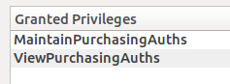

ViewPurchasingAuths lets the user view all authorizations and their assignment to users but not create, edit or delete any authorizations.
MaintainPurchasingAuths lets the user view, create, edit, or delete any authorizations. Only assign this privilege to the user who is responsible for setting up the purchasing authorization matrix and assignment to users.

User Setup
To define purchasing authorizations, the user processing the release must also be defined as a Purchasing Agent. This is assigned to the user in the User Setup screen.

Purchasing Authorizations
Purchasing Authorizations are set up on the Purchasing Authorization screen. This is found on the menu Purchase → Purchase Order → Purchase Authorizations...

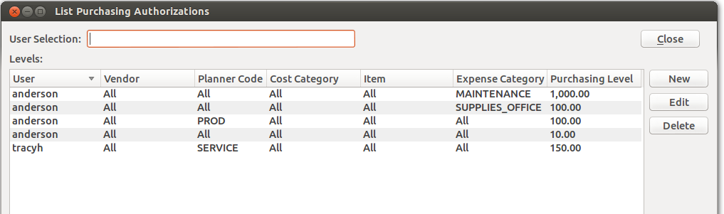
To filter the list to a particular user in the system, start typing their username in the User Selection area. This will automatically filter the Purchasing Levels list.

Purchasing Level Hierarchy
Purchasing Levels work in a hierarchy from most specific to least specific, and you must have authority for all purchase order items in order to release the purchase order. If there is an item on the purchase order that you do not have a purchasing level for, the purchase order release will be prevented.
The levels work from most specific to least specific. If you are authorized for all items to the value of $1000, but have a more specific level for one items at $500, you will only be allowed to release orders for that item to a value of $500. If you do not have a specific level for an item, the system will look for a less detailed level before failing if it cannot find a suitable level.

Maintaining Purchasing Levels
To create a new purchasing level, press the New button.
To edit an existing purchasing level, select the level from the list and press the Edit button.
To remove a purchasing level, select the level form the list and press the Delete button.

NOTE: Changes to purchasing levels take effect immediately. You do not need to restart the system or rescan privileges to changes to take effect.

Purchasing Levels
Purchasing Levels follow similar groupings as the Item Inventory. You also need to authorise non-physical purchases (Expense Categories).
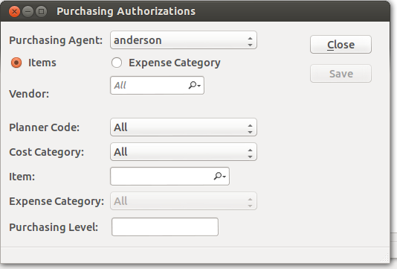
Select the User (Purchasing Agent) that you want to assign a purchasing level to.

Physical Items
Select the Items radio to enter an item based purchasing level.
For physical, purchased, items you have the ability to restrict the users level using Vendor, Item Planner Code, Cost Category and/or specific Item.
If you do not enter a value, the system will assume you wish to apply the selection to All elements. You can then set the value level that this user can purchase up to.

Non-Physical Items
Purchase Orders can also be for non-physical expense items. Select the Expense Category radio to enter an expense based purchasing level.
Choose an appropriate Expense Category (or All). You can then set the value level that this user can purchase up to.

Press Save button to save the level.

Purchase Releases
On all screens where you are able to release a purchase order, when you release that order the system will check each purchase order item to see if the user logged in has the authority to release that item. If the user has insufficient authority on ANY of the items, the entire purchase order cannot be released and an appropriate message will be displayed.
If the user releasing the order has sufficient authority for all items on the purchase order, the order will be released without any messages, per the standard xTuple system.

Printing Purchase Orders
Subtle changes have been made to the standard behaviour of the xTuple system when it comes to printing a purchase order. A purchase order is now unable to be printed unless it is in the Released (Open) status. This approach is to prevent un-authorized parties from creating a purchase order and then sending the printed copy to an external party.
First, an appropriately authorised person must release the purchase order, then it can be printed as normal.

